Git Introduction : Git is a free, open source distributed version control system tool designed to handle everything from small to very large projects with speed and efficiency. It was created by Linus Torvalds in 2005 to develop Linux Kernel.

What is Git Bash?
Git Bash is an application for Microsoft Windows environments which provides an layer for a Git command line experience. Bash is an acronym for Bourne Again Shell. A shell is a terminal application used to interface with an operating system through written commands.

Git Bash is a package that installs Bash, some common bash utilities, and Git on a Windows operating system.

Link to download git : https://git-scm.com/download/win/
Command to check git version : git --version
Command to clear screen : clear

How do I learn Git commands?
A basic overview of how Git works:
- Create a “repository” (project) with a git hosting tool (like Bitbucket)
- Copy (or clone) the repository to your local machine
- Add a file to your local repo and “commit” (save) the changes
- “Push” your changes to your master branch
- Make a change to your file with a git hosting tool and commit
- “Pull” the changes to your local machine
- Create a “branch” (version), make a change, commit the change
- Open a “pull request”.
- “Merge” your branch to the master branch

Git Tutorial – A few Operations & Commands
Some of the basic operations in Git are:
- Initialize
- Add
- Commit
- Pull
- Push
Some advanced Git operations are:
- Branching
- Merging
- Rebasing
Let me first give you a brief idea about how these operations work with the Git repositories. Take a look at the architecture of Git below:
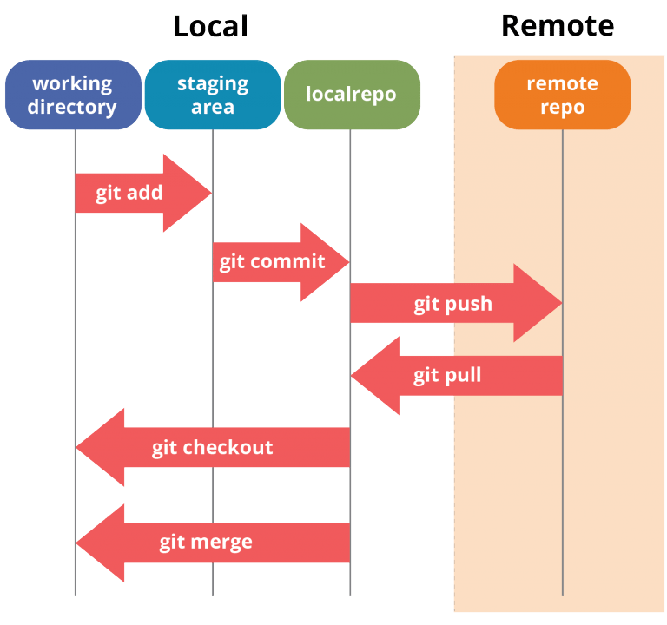

Install Git On Windows
Step 1:
To download the latest version of Git, click on the link below:
Download Git for Windows
Great! Your file is being downloaded.
Step 2:
After your download is complete, Run the .exe file in your system.
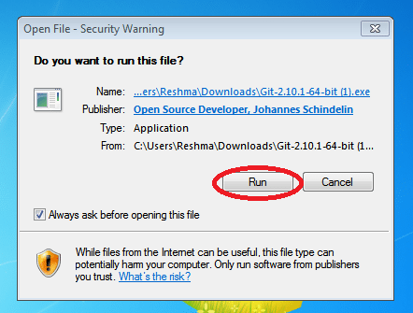
Step 3:
After you have pressed the Run button and agreed to the license, you will find a window prompt to select components to be installed.
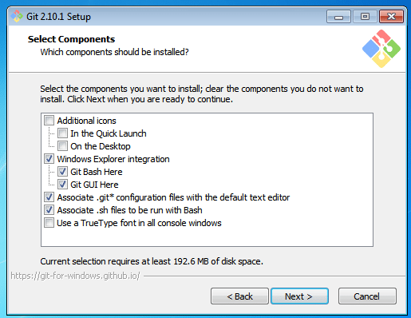
After you have made selection of your desired components, click on Next>.
Step 4:
The next prompt window will let you choose the adjustment of your path environment. This is where you decide how do you want to use Git.
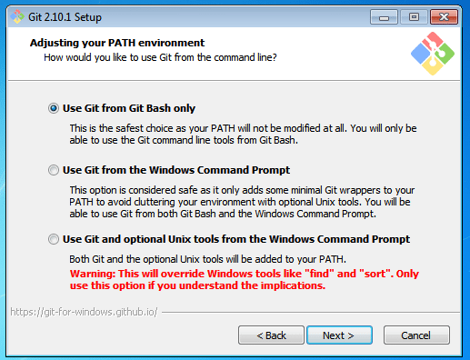
You can select any of the three options according to your needs. But for beginners, I recommend using Use Git From Git Bash Only
Step 5:
The next step is to choose features for your Git. You get three options and you can choose any of them, all of them or none of them as per your needs. Let me tell you what these features are:
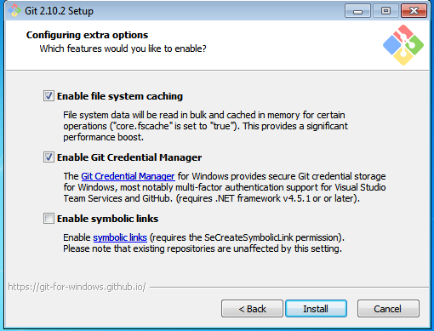
The first is the option to Enable file system caching.
Caching is enabled through Cache manager, which operates continuously while Windows is running. File data in the system file cache is written to the disk at intervals determined by the operating system, and the memory previously used by that file data is freed.
The second option is to enable Git Credential Manager.
The Git Credential Manager for Windows (GCM) is a credential helper for Git. It securely stores your credentials in the Windows CM so that you only need to enter them once for each remote repository you access. All future Git commands will reuse the existing credentials.
The third option is to Enable symbolic links.
Symbolic links or symlinks are nothing but advanced shortcuts. You can create symbolic links for each individual file or folder, and these will appear like they are stored in the folder with symbolic link.
I have selected the first two features only.
Step 6:
Choose your terminal.
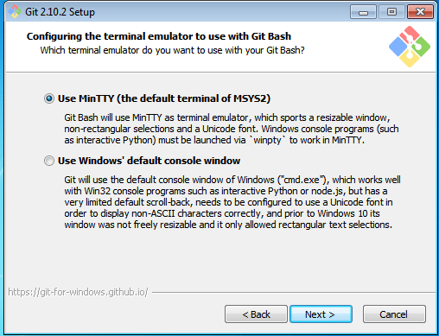
You can choose one from the options.
The default terminal of MYSYS2 which is a collection of GNU utilities like bash, make, gawk and grep to allow building of applications and programs which depend on traditionally UNIX tools to be present.
Or you can choose the window’s default console window (cmd.exe).
Step 7:
Now you have got all you need. Select Launch Git Bash and click on Finish.
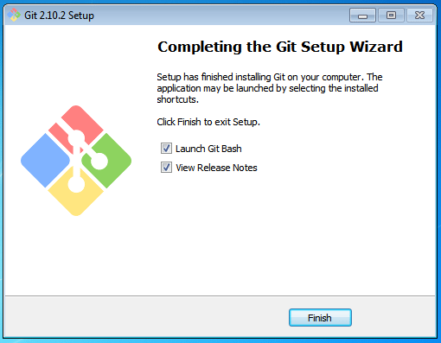
This will launch Git Bash on your screen which looks like the snapshot below:
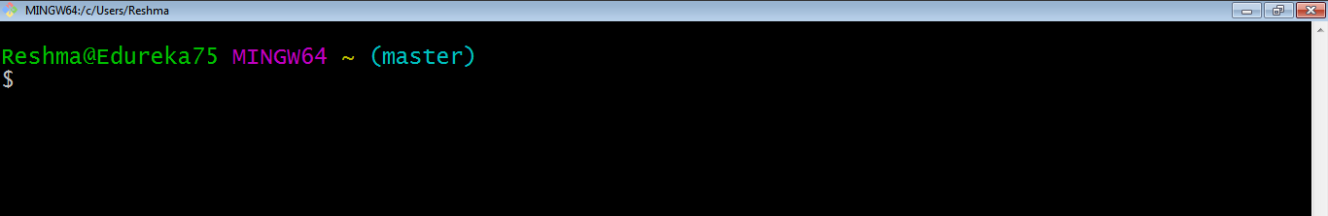
Step 8:
Let us proceed with configuring Git with your username and email. In order to do that, type the following commands in your Git Bash:
git config - - global user.name "<your name>"
git config - - global user.email "<your email>"
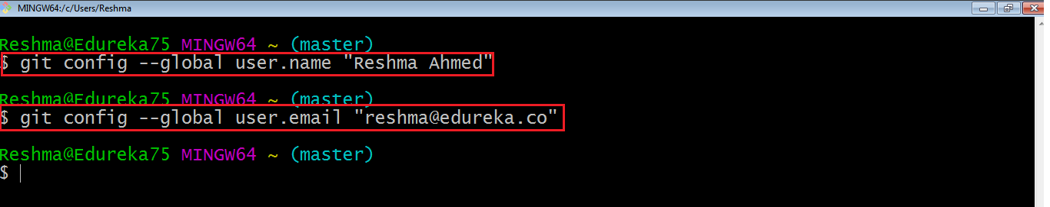
It is important to configure your Git because any commits that you make are associated with your configuration details.
If you want to view all your configuration details, use the command below: git config - - list
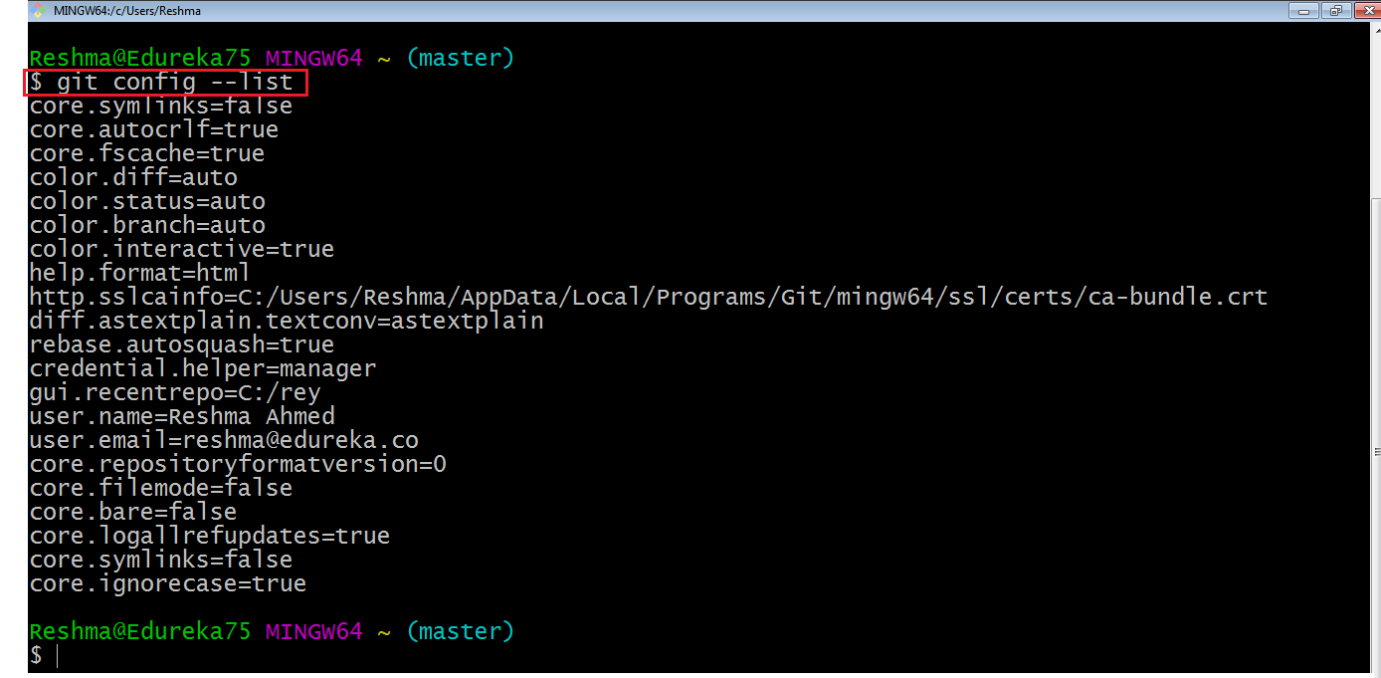
This is how you install and setup GIT on Windows.
What is Git Bash used for?
This Git Bash Tutorial focuses on the commands and operations that can be used on Git Bash.
Note: The commands cannot be executed on GitHub. You can check out this blog on GitHub tutorial for reference.

How do I navigate Git Bash?
After installing Git in your Windows system, just open your folder/directory where you want to store all your project files; right click and select ‘Git Bash here’.
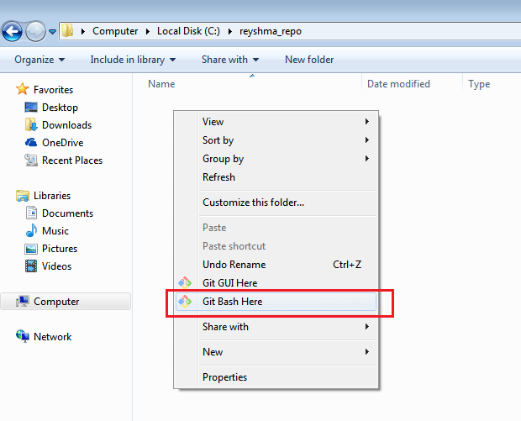
This will open up Git Bash terminal where you can enter commands to perform various Git operations.
Now, the next task is to initialize your repository.

Initialize
In order to do that, we use the command git init. Please refer to the below screenshot.
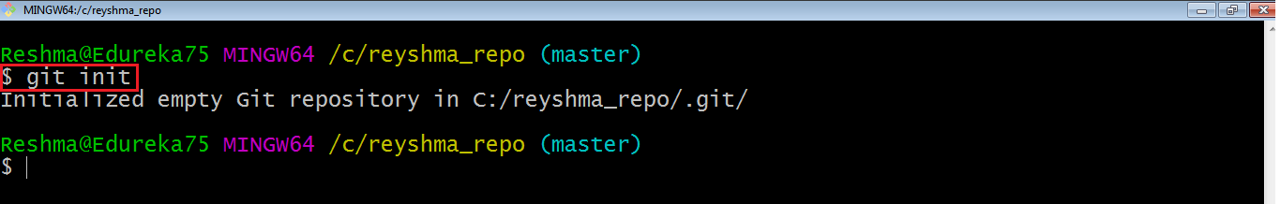
git init creates an empty Git repository or re-initializes an existing one. It basically creates a .git directory with sub directories and template files. Running a git init in an existing repository will not overwrite things that are already there. It rather picks up the newly added templates.
Now that my repository is initialized, let me create some files in the directory/repository. For e.g. I have created two text files namely edureka1.txt and edureka2.txt.
Let’s see if these files are in my index or not using the command git status. The index holds a snapshot of the content of the working tree/directory, and this snapshot is taken as the contents for the next change to be made in the local repository.

Git status
The git status command lists all the modified files which are ready to be added to the local repository.
Let us type in the command to see what happens:
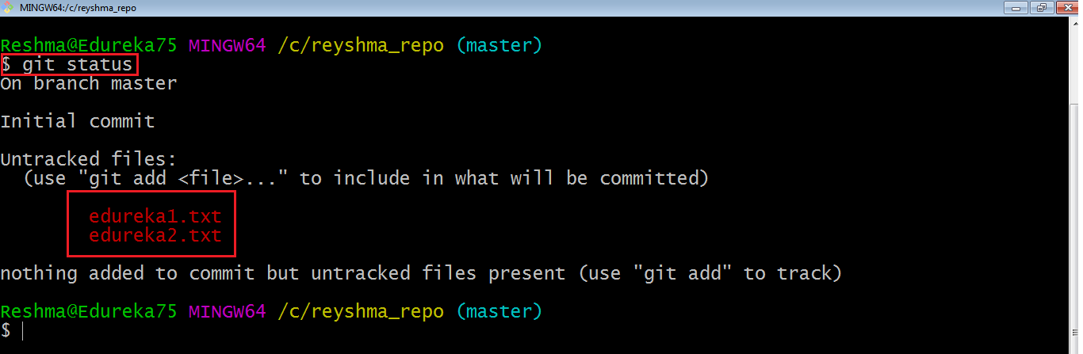
This shows that I have two files which are not added to the index yet. This means I cannot commit changes with these files unless I have added them explicitly in the index.

Add
This command updates the index using the current content found in the working tree and then prepares the content in the staging area for the next commit.
Thus, after making changes to the working tree, and before running the commit command, you must use the add command to add any new or modified files to the index. For that, use the commands below:
git add <directory>
Or git add <file>
Let me demonstrate the git add for you so that you can understand it better.
I have created two more files edureka3.txt and edureka4.txt. Let us add the files using the command git add -A. This command will add all the files to the index which are in the directory but not updated in the index yet.
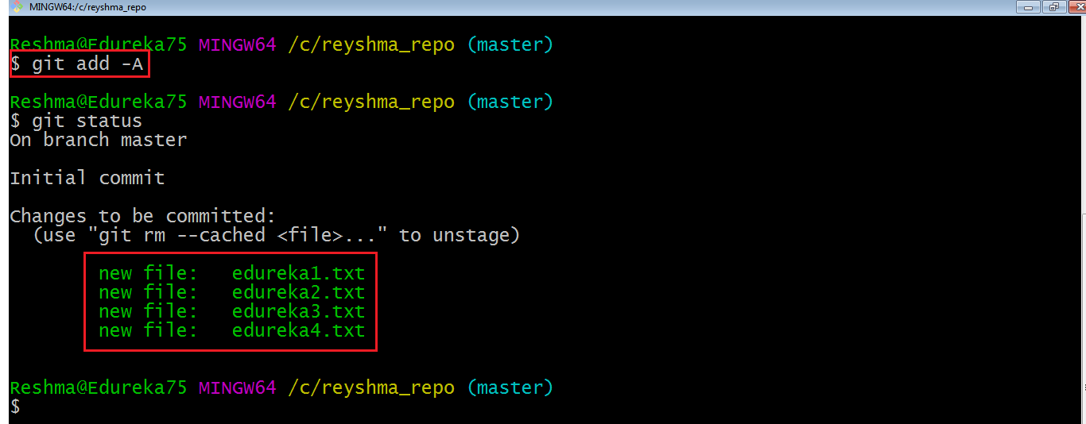
Now that the new files are added to the index, you are ready to commit them.

Commit
It refers to recording snapshots of the repository at a given time. Committed snapshots will never change unless done explicitly. Let me explain how commit works with the diagram below: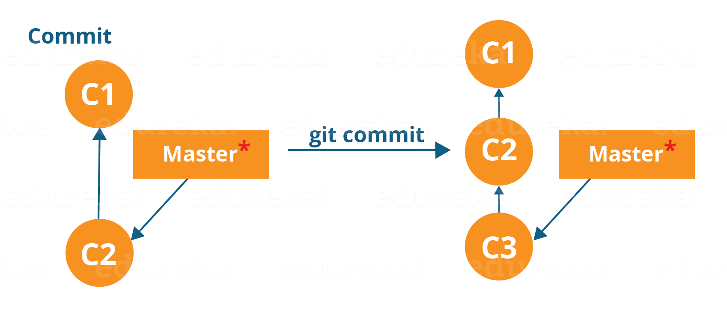
Here, C1 is the initial commit, i.e. the snapshot of the first change from which another snapshot is created with changes named C2. Note that the master points to the latest commit.
Now, when I commit again, another snapshot C3 is created and now the master points to C3 instead of C2.
Git aims to keep commits as lightweight as possible. So, it doesn’t blindly copy the entire directory every time you commit; it includes commit as a set of changes, or “delta” from one version of the repository to the other. In easy words, it only copies the changes made in the repository.
You can commit by using the command below:
git commit
This will commit the staged snapshot and will launch a text editor prompting you for a commit message.
Or you can use:
git commit -m “<message>”
Let’s try it out.
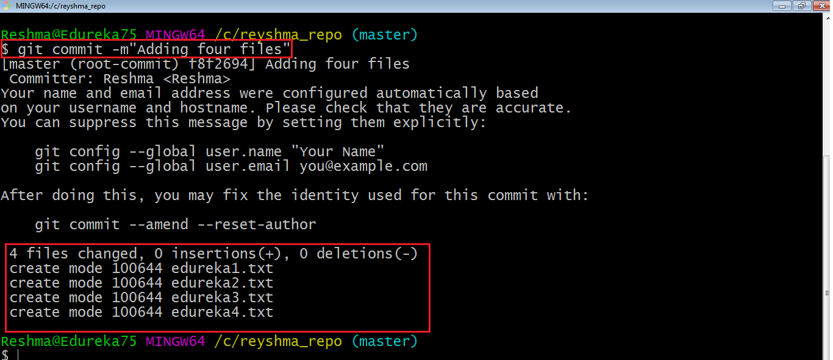
As you can see above, the git commit command has committed the changes in the four files in the local repository.
Now, if you want to commit a snapshot of all the changes in the working directory at once, you can use the command below:
git commit -a
I have created two more text files in my working directory viz. edureka5.txt and edureka6.txt but they are not added to the index yet.
I am adding edureka5.txt using the command:
git add edureka5.txt
I have added edureka5.txt to the index explicitly but not edureka6.txt and made changes in the previous files. I want to commit all changes in the directory at once. Refer to the below snapshot.
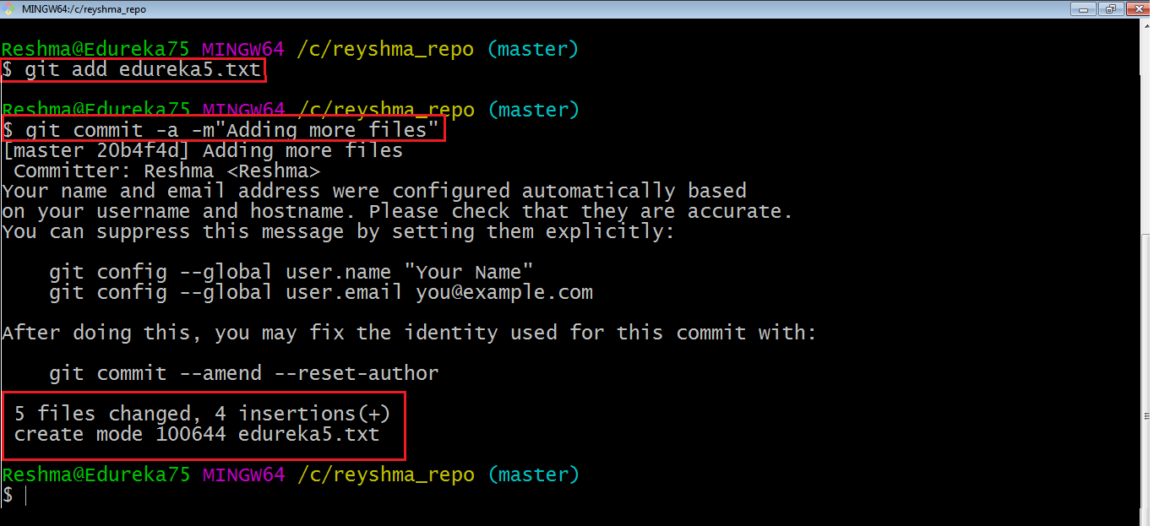
This command will commit a snapshot of all changes in the working directory but only includes modifications to tracked files i.e. the files that have been added with git add at some point in their history. Hence, edureka6.txt was not committed because it was not added to the index yet. But changes in all previous files present in the repository were committed, i.e. edureka1.txt, edureka2.txt, edureka3.txt, edureka4.txt and edureka5.txt.
Now I have made my desired commits in my local repository.
Note that before you affect changes to the central repository you should always pull changes from the central repository to your local repository to get updated with the work of all the collaborators that have been contributing in the central repository. For that we will use the pull command.
Pull
The git pull command fetches changes from a remote repository to a local repository. It merges upstream changes in your local repository, which is a common task in Git based collaborations.
But first, you need to set your central repository as origin using the command:
git remote add origin <link of your central repository>
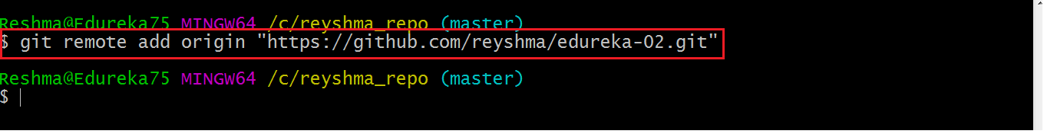
Now that my origin is set, let us extract files from the origin using pull. For that use the command:
git pull origin master
This command will copy all the files from the master branch of remote repository to your local repository.
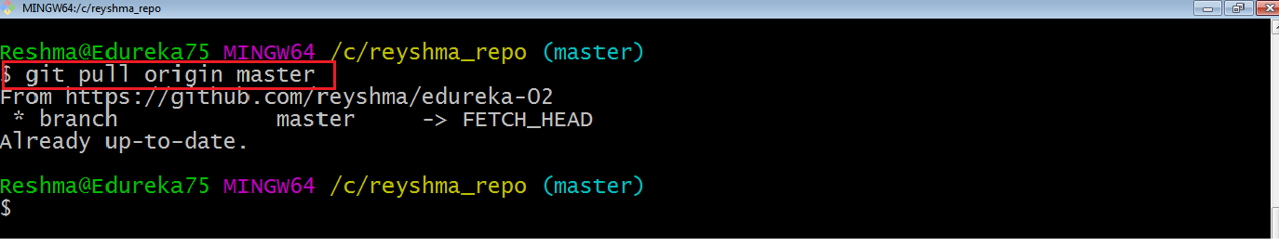
Since my local repository was already updated with files from master branch, hence the message is Already up-to-date. Refer to the screen shot above.
Note: One can also try pulling files from a different branch using the following command:
git pull origin <branch-name>
Your local Git repository is now updated with all the recent changes. It is time you make changes in the central repository by using the push command.

Push
This command transfers commits from your local repository to your remote repository. It is the opposite of pull operation.
Pulling imports commits to local repositories whereas pushing exports commits to the remote repositories .
The use of git push is to publish your local changes to a central repository. After you’ve accumulated several local commits and are ready to share them with the rest of the team, you can then push them to the central repository by using the following command:
git push <remote>
Note : This remote refers to the remote repository which had been set before using the pull command.
This pushes the changes from the local repository to the remote repository along with all the necessary commits and internal objects. This creates a local branch in the destination repository.
Let me demonstrate it for you.
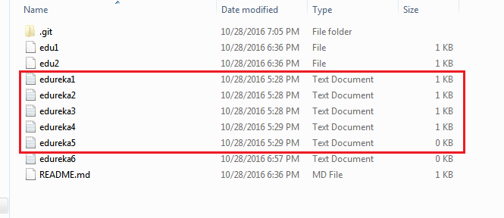
The above files are the files which we have already committed previously in the commit section and they are all “push-ready“. I will use the command git push origin master to reflect these files in the master branch of my central repository.
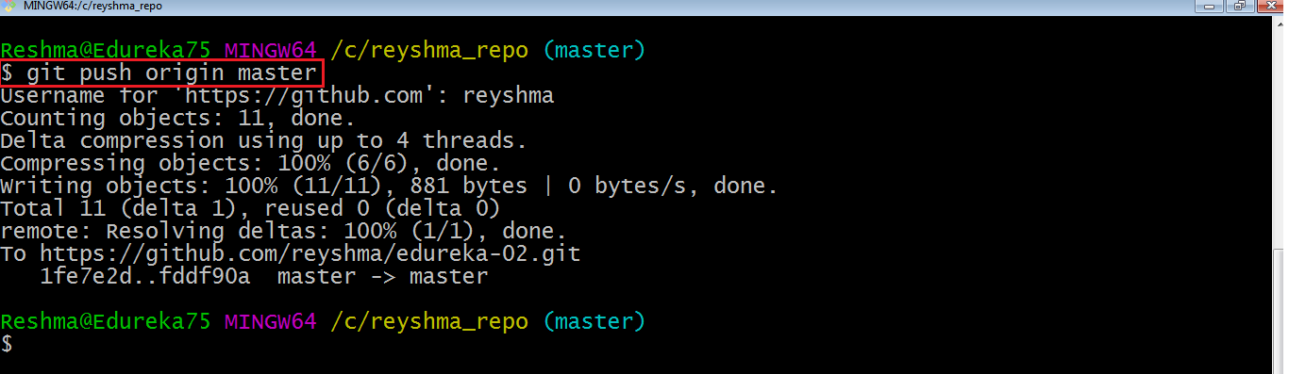
Let us now check if the changes took place in my central repository.
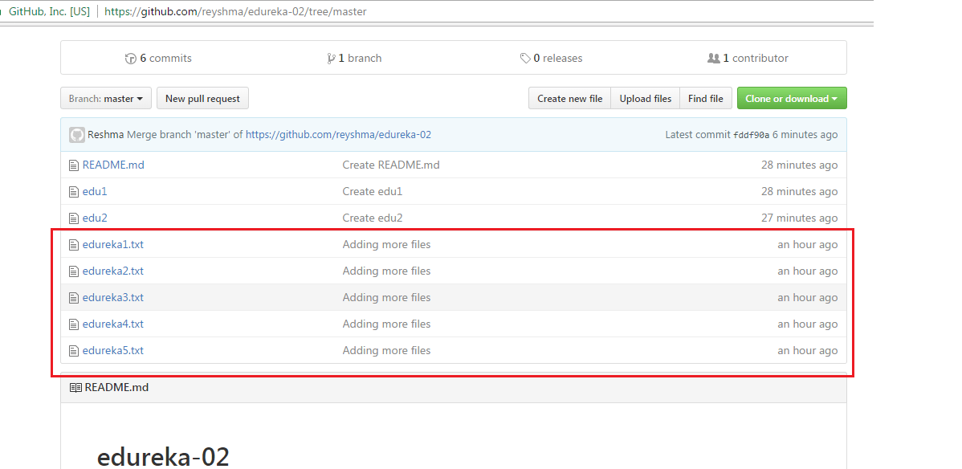
Yes, it did. :-)
To prevent overwriting, Git does not allow push when it results in a non-fast forward merge in the destination repository.
Note: A non-fast forward merge means an upstream merge i.e. merging with ancestor or parent branches from a child branch.
To enable such merge, use the command below:
git push <remote> --force
The above command forces the push operation even if it results in a non-fast forward merge.
At this point of this Git Tutorial, I hope you have understood the basic commands of Git. Now, let’s take a step further to learn branching and merging in Git.

Branching
Branches in Git are nothing but pointers to a specific commit. Git generally prefers to keep its branches as lightweight as possible.
There are basically two types of branches viz. local branches and remote tracking branches.
A local branch is just another path of your working tree. On the other hand, remote tracking branches have special purposes. Some of them are:
- They link your work from the local repository to the work on central repository.
- They automatically detect which remote branches to get changes from, when you use git pull.
You can check what your current branch is by using the command:
git branch
The one mantra that you should always be chanting while branching is “branch early, and branch often”
To create a new branch we use the following command:
git branch <branch-name>
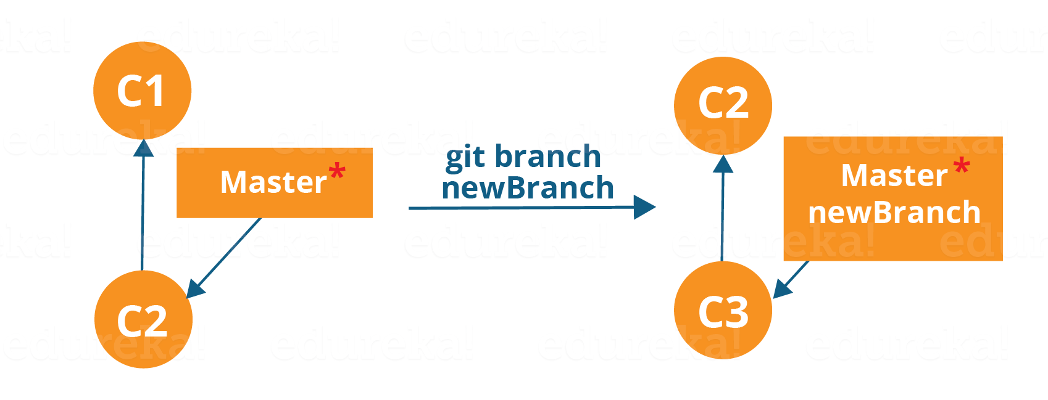
The diagram above shows the workflow when a new branch is created. When we create a new branch it originates from the master branch itself.
Since there is no storage/memory overhead with making many branches, it is easier to logically divide up your work rather than have big chunky branches.
Now, let us see how to commit using branches.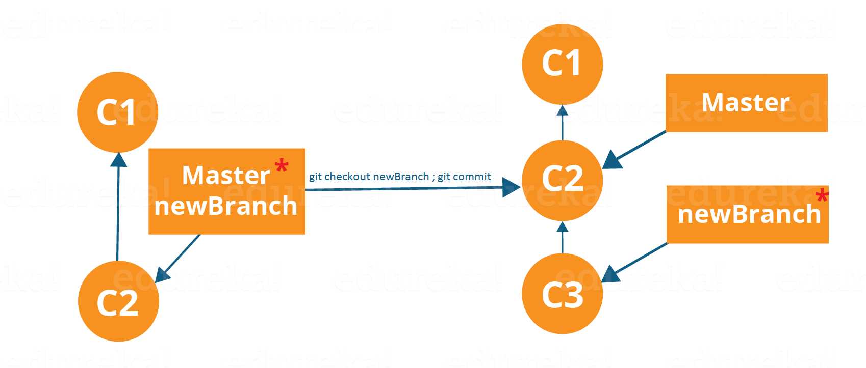
Branching includes the work of a particular commit along with all parent commits. As you can see in the diagram above, the newBranch has detached itself from the master and hence will create a different path.
Use the command below:
git checkout <branch_name> and then
git commit
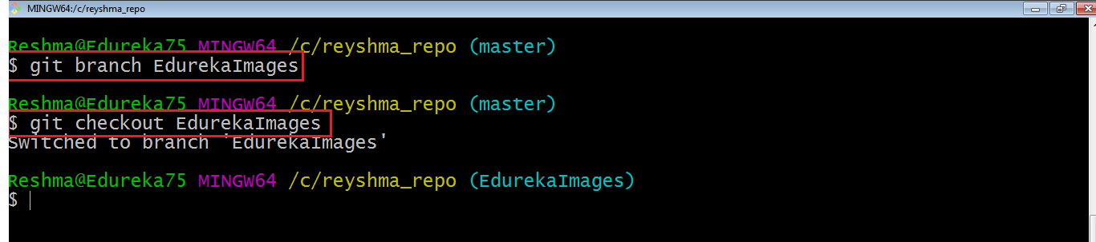
Here, I have created a new branch named “EdurekaImages” and switched on to the new branch using the command git checkout .
One shortcut to the above commands is:
git checkout -b[ branch_name]
This command will create a new branch and checkout the new branch at the same time.
Now while we are in the branch EdurekaImages, add and commit the text file edureka6.txt using the following commands:
git add edureka6.txt
git commit -m"adding edureka6.txt"

Merging
Merging is the way to combine the work of different branches together. This will allow us to branch off, develop a new feature, and then combine it back in.
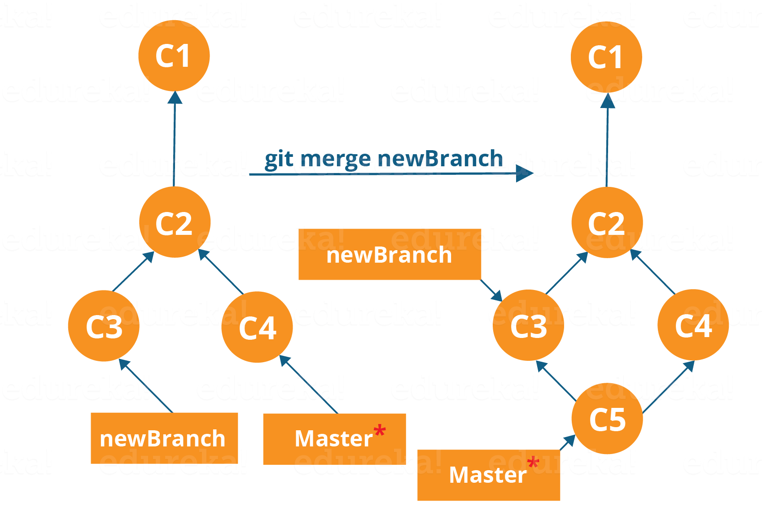
The diagram above shows us two different branches-> newBranch and master. Now, when we merge the work of newBranch into master, it creates a new commit which contains all the work of master and newBranch.
Now let us merge the two branches with the command below:

git merge <branch_name>
It is important to know that the branch name in the above command should be the branch you want to merge into the branch you are currently checking out. So, make sure that you are checked out in the destination branch.
Now, let us merge all of the work of the branch EdurekaImages into the master branch. For that I will first checkout the master branch with the command git checkout master and merge EdurekaImages with the command git merge EdurekaImages
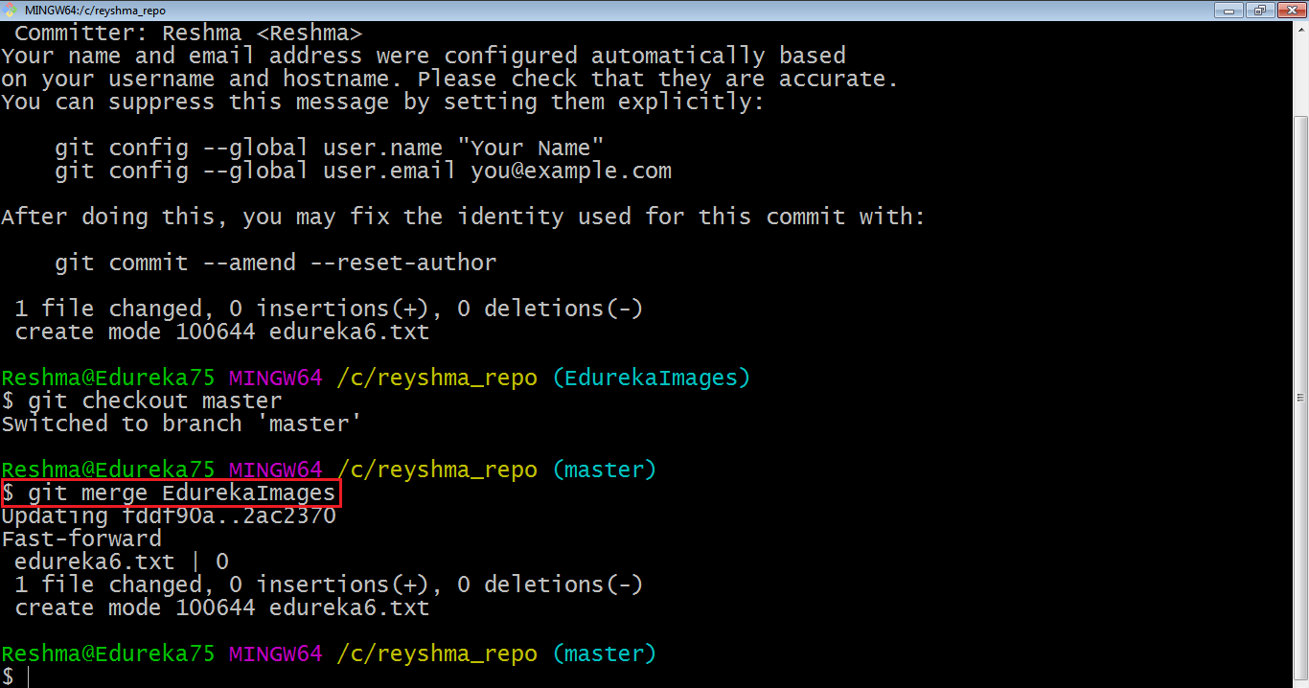
As you can see above, all the data from the branch name are merged to the master branch. Now, the text file edureka6.txt has been added to the master branch.
Merging in Git creates a special commit that has two unique parents.

Rebasing
This is also a way of combining the work between different branches. Rebasing takes a set of commits, copies them and stores them outside your repository.
The advantage of rebasing is that it can be used to make linear sequence of commits. The commit log or history of the repository stays clean if rebasing is done.
Let us see how it happens.
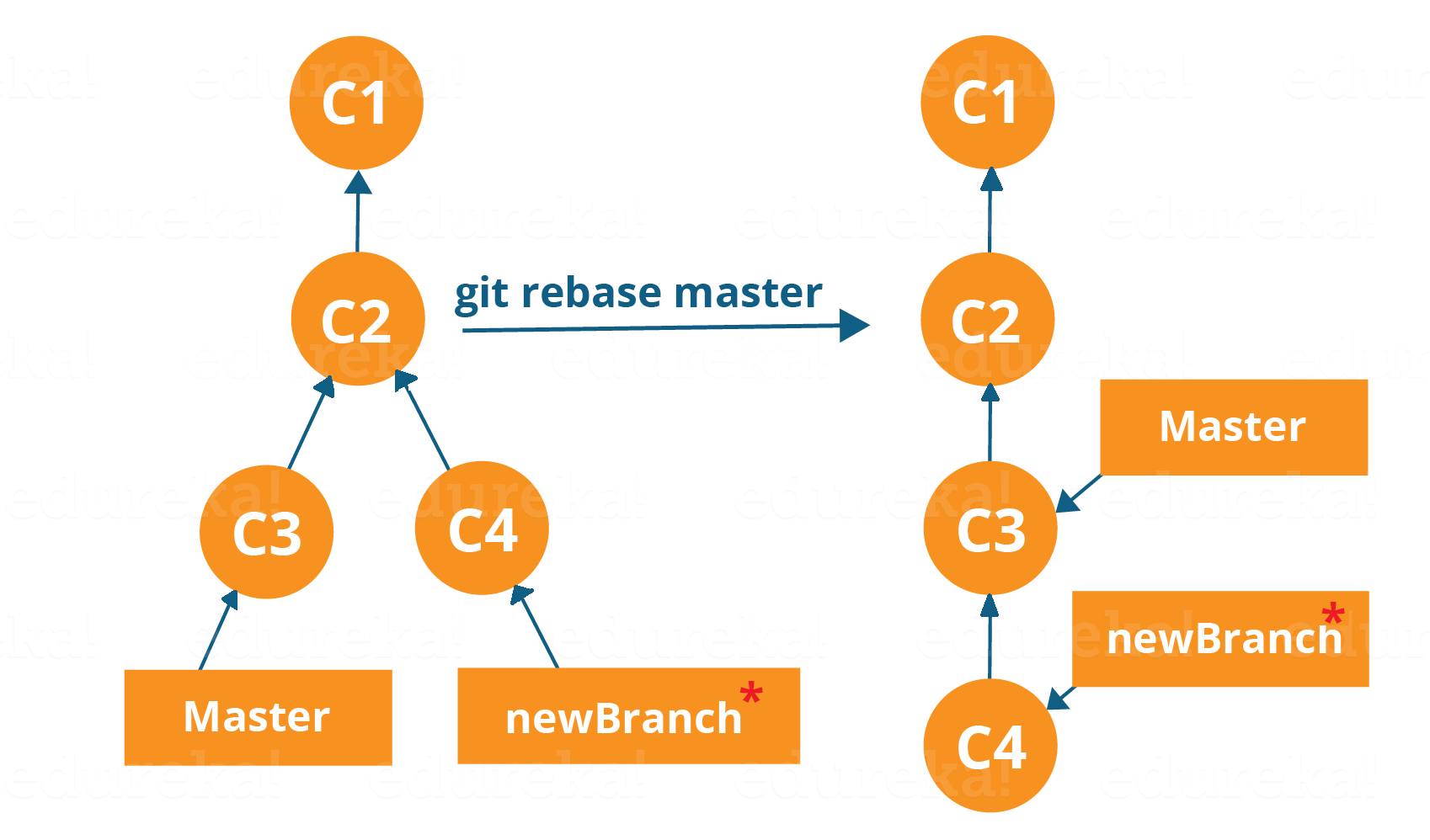
Now, our work from newBranch is placed right after master and we have a nice linear sequence of commits.
Note: Rebasing also prevents upstream merges, meaning you cannot place master right after newBranch.
Now, to rebase master, type the command below in your Git Bash:
git rebase master
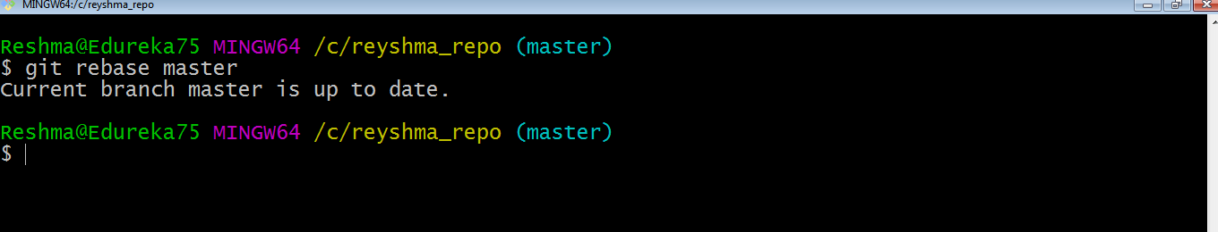
This command will move all our work from current branch to the master. They look like as if they are developed sequentially, but they are developed parallelly.
Commands and Questions

git config --global user.name "Gaurav Kothari"
git config --global user.email "kotharigaurav6@gmail.com"

git init
git status
git add <name> (specific file)
git add -A (for all content)
git commit -m "my first commit"
git remote add origin https://github.com/kotharigaurav6/volcanus.git
git remote remove origin
git remote add origin https://github.com/kotharigaurav6/ceve56.git
git clone https://github.com/kotharigaurav6/ceve56.git
git branch (to check current branch)
git push -u origin master
(or) git push https://github.com/kotharigaurav6/ceve56.git
git pull origin master
git branch (local machine branch)
git branch -r (remote machine branch)
git branch gaurav (create a new branch)
git checkout gaurav (need to come in existing branch)
git commit -m"again i am commiting"
git push origin main --force
git checkout --force master
git show <object>(shows any specific commit)
git log (shows all commit) --> needs to quit by pressing q key

come in main or master branch then,
git merge <child branch>

In Git, command-line options often consist of single-letter flags that are used to modify the behavior of various commands. Here's an explanation of the flags you provided:

1. `-u`: This flag stands for "upstream." It is commonly used with `git push` to specify the remote tracking branch that your local branch should be pushed to. For example, `git push -u origin main` sets the upstream branch for the local `main` branch to the remote branch named `main` in the `origin` repository. After setting the upstream branch, subsequent `git push` commands without specifying a remote branch will automatically push to the specified upstream branch.

2. `-M`: This flag is used with `git branch` to force a rename of a branch. For example, `git branch -M old-branch new-branch` renames the branch named `old-branch` to `new-branch`. If `new-branch` already exists, it will be overwritten.

3. `-m`: This flag is also used with `git branch` to move a branch to a new starting point. For example, `git branch -m branch-name new-starting-point` moves the branch named `branch-name` to start from the commit specified by `new-starting-point`.

4. `-r`: This flag is used with `git branch` or `git fetch` to display or manage remote-tracking branches. With `git branch -r`, you can list all the remote branches in your repository. When used with `git fetch`, it fetches the changes from the remote repository but does not integrate them into your working directory.

5. `-a`: This flag is used with `git branch` to show all branches, including local and remote-tracking branches. It is equivalent to using `git branch -a`.

6. `-A`: This flag is used with `git add` to stage all changes, including new files and deletions. For example, `git add -A` will stage all the changes in the working directory, making them ready for the next commit.

Remember that the usage of these flags may vary depending on the specific Git command you are running, and it's always a good idea to consult the official Git documentation or use the `git --help` command for detailed information about a particular command and its options.

1. What is the command to initialize a new Git repository in a directory?
2. How do you check the status of your Git repository and see which files have been modified?
3. How do you add files to the staging area using the "git add" command?
4. Explain the difference between "git add ." and "git add -A" commands.
5. What does the "git commit" command do, and how do you write a commit message?
6. What is the command to add all the modified files in the working directory to the staging area?
7. What is the "git status" command used for, and how can it help you track changes in your repository?
8. How do you create and switch to a new branch using the "git checkout" command?
9. Explain the purpose of the "git merge" command and how it is used to combine branches.
10. How can you push your local changes to a remote repository using "git push"?
11. How do you create a new branch in Git?
12. How do you switch to a different branch in Git?
13. What command is used to commit changes from the staging area to the Git repository?
14. How do you see the commit history in a Git repository?
15. What is the command to add a remote repository to your local Git repository?
16. How do you push your changes to a remote repository?
17. How do you pull changes from a remote repository to your local repository?
18. What command do you use to merge two branches in Git?
19. What is the "git clone" command used for, and how do you use it to create a local copy of a remote repository?
20. How can you see the changes made in a specific commit using "git show"?

Gaurav.Kothari@IB-SEZ-LAP-662 MINGW64 ~/Desktop/Git Demo (master)
$ git init
Initialized empty Git repository in C:/Users/Gaurav.Kothari/Desktop/Git Demo/.git/

Gaurav.Kothari@IB-SEZ-LAP-662 MINGW64 ~/Desktop/Git Demo (master)
$ git status
On branch master

No commits yet

Untracked files:
(use "git add <file>..." to include in what will be committed)
demo1.txt
demo2.txt

nothing added to commit but untracked files present (use "git add" to track)

Gaurav.Kothari@IB-SEZ-LAP-662 MINGW64 ~/Desktop/Git Demo (master)
$ git add -A

Gaurav.Kothari@IB-SEZ-LAP-662 MINGW64 ~/Desktop/Git Demo (master)
$ git commit -m "my first commit"
[master (root-commit) 50f499e] my first commit
2 files changed, 0 insertions(+), 0 deletions(-)
create mode 100644 demo1.txt
create mode 100644 demo2.txt

Gaurav.Kothari@IB-SEZ-LAP-662 MINGW64 ~/Desktop/Git Demo (master)
$ git branch -M main

Gaurav.Kothari@IB-SEZ-LAP-662 MINGW64 ~/Desktop/Git Demo (main)
$ git remote add origin "https://github.com/kotharigaurav6/programming.git"

Gaurav.Kothari@IB-SEZ-LAP-662 MINGW64 ~/Desktop/Git Demo (main)
$ git push -u origin main
To https://github.com/kotharigaurav6/programming.git
! [rejected] main -> main (fetch first)
error: failed to push some refs to 'https://github.com/kotharigaurav6/programming.git'
hint: Updates were rejected because the remote contains work that you do
hint: not have locally. This is usually caused by another repository pushing
hint: to the same ref. You may want to first integrate the remote changes
hint: (e.g., 'git pull ...') before pushing again.
hint: See the 'Note about fast-forwards' in 'git push --help' for details.

Gaurav.Kothari@IB-SEZ-LAP-662 MINGW64 ~/Desktop/Git Demo (main)
$ git push -u origin main --force
Enumerating objects: 3, done.
Counting objects: 100% (3/3), done.
Delta compression using up to 4 threads
Compressing objects: 100% (2/2), done.
Writing objects: 100% (3/3), 221 bytes | 73.00 KiB/s, done.
Total 3 (delta 0), reused 0 (delta 0), pack-reused 0
To https://github.com/kotharigaurav6/programming.git
+ 222fb40...50f499e main -> main (forced update)
branch 'main' set up to track 'origin/main'.

Gaurav.Kothari@IB-SEZ-LAP-662 MINGW64 ~/Desktop/Git Demo (main)
$ git clone "https://github.com/kotharigaurav6/programming.git"

Cloning into 'programming'...
remote: Enumerating objects: 3, done.
remote: Counting objects: 100% (3/3), done.
remote: Compressing objects: 100% (2/2), done.
remote: Total 3 (delta 0), reused 3 (delta 0), pack-reused 0
Receiving objects: 100% (3/3), done.

Gaurav.Kothari@IB-SEZ-LAP-662 MINGW64 ~/Desktop/Git Demo (main)
$ git pull "https://github.com/kotharigaurav6/programming.git"
From https://github.com/kotharigaurav6/programming
* branch HEAD -> FETCH_HEAD
Already up to date.

Gaurav.Kothari@IB-SEZ-LAP-662 MINGW64 ~/Desktop/Git Demo (main)
$ git pull -u origin main
error: unknown switch `u'
usage: git pull [<options>] [<repository> [<refspec>...]]

-v, --verbose be more verbose
-q, --quiet be more quiet
--progress force progress reporting
--recurse-submodules[=<on-demand>]
control for recursive fetching of submodules

Options related to merging
-r, --rebase[=(false|true|merges|interactive)]
incorporate changes by rebasing rather than merging
-n do not show a diffstat at the end of the merge
--stat show a diffstat at the end of the merge
--log[=<n>] add (at most <n>) entries from shortlog to merge commit message
--signoff[=...] add a Signed-off-by trailer
--squash create a single commit instead of doing a merge
--commit perform a commit if the merge succeeds (default)
--edit edit message before committing
--cleanup <mode> how to strip spaces and #comments from message
--ff allow fast-forward
--ff-only abort if fast-forward is not possible
--verify control use of pre-merge-commit and commit-msg hooks
--verify-signatures verify that the named commit has a valid GPG signature
--autostash automatically stash/stash pop before and after
-s, --strategy <strategy>
merge strategy to use
-X, --strategy-option <option=value>
option for selected merge strategy
-S, --gpg-sign[=<key-id>]
GPG sign commit
--allow-unrelated-histories
allow merging unrelated histories

Options related to fetching
--all fetch from all remotes
-a, --append append to .git/FETCH_HEAD instead of overwriting
--upload-pack <path> path to upload pack on remote end
-f, --force force overwrite of local branch
-t, --tags fetch all tags and associated objects
-p, --prune prune remote-tracking branches no longer on remote
-j, --jobs[=<n>] number of submodules pulled in parallel
--dry-run dry run
-k, --keep keep downloaded pack
--depth <depth> deepen history of shallow clone
--shallow-since <time>
deepen history of shallow repository based on time
--shallow-exclude <revision>
deepen history of shallow clone, excluding rev
--deepen <n> deepen history of shallow clone
--unshallow convert to a complete repository
--update-shallow accept refs that update .git/shallow
--refmap <refmap> specify fetch refmap
-o, --server-option <server-specific>
option to transmit
-4, --ipv4 use IPv4 addresses only
-6, --ipv6 use IPv6 addresses only
--negotiation-tip <revision>
report that we have only objects reachable from this object
--show-forced-updates
check for forced-updates on all updated branches
--set-upstream set upstream for git pull/fetch

Gaurav.Kothari@IB-SEZ-LAP-662 MINGW64 ~/Desktop/Git Demo (main)
$ git pull origin main
From https://github.com/kotharigaurav6/programming
* branch main -> FETCH_HEAD
Already up to date.

Gaurav.Kothari@IB-SEZ-LAP-662 MINGW64 ~/Desktop/Git Demo (main)
$ git pull "https://github.com/kotharigaurav6/programming.git"
remote: Enumerating objects: 4, done.
remote: Counting objects: 100% (4/4), done.
remote: Compressing objects: 100% (3/3), done.
remote: Total 3 (delta 0), reused 0 (delta 0), pack-reused 0
Unpacking objects: 100% (3/3), 1018 bytes | 53.00 KiB/s, done.
From https://github.com/kotharigaurav6/programming
* branch HEAD -> FETCH_HEAD
Updating 50f499e..883d30e
Fast-forward
Readme.txt | Bin 0 -> 1062 bytes
1 file changed, 0 insertions(+), 0 deletions(-)
create mode 100644 Readme.txt

Gaurav.Kothari@IB-SEZ-LAP-662 MINGW64 ~/Desktop/Git Demo (main)
$ git switch -c gaurav
Switched to a new branch 'gaurav'

Gaurav.Kothari@IB-SEZ-LAP-662 MINGW64 ~/Desktop/Git Demo (gaurav)
$ git branch -r
origin/main

Gaurav.Kothari@IB-SEZ-LAP-662 MINGW64 ~/Desktop/Git Demo (gaurav)
$ git branch
* gaurav
main

Gaurav.Kothari@IB-SEZ-LAP-662 MINGW64 ~/Desktop/Git Demo (gaurav)
$ git remove branch gaurav
git: 'remove' is not a git command. See 'git --help'.

The most similar command is
remote

Gaurav.Kothari@IB-SEZ-LAP-662 MINGW64 ~/Desktop/Git Demo (gaurav)
$ git switch -
Switched to branch 'main'
Your branch is ahead of 'origin/main' by 1 commit.
(use "git push" to publish your local commits)

Gaurav.Kothari@IB-SEZ-LAP-662 MINGW64 ~/Desktop/Git Demo (main)
$ git switch gk
fatal: invalid reference: gk

Gaurav.Kothari@IB-SEZ-LAP-662 MINGW64 ~/Desktop/Git Demo (main)
$ git branch -r
origin/main

Gaurav.Kothari@IB-SEZ-LAP-662 MINGW64 ~/Desktop/Git Demo (main)
$ git branch
gaurav
* main

Gaurav.Kothari@IB-SEZ-LAP-662 MINGW64 ~/Desktop/Git Demo (main)
$ git branch -r
origin/main

Gaurav.Kothari@IB-SEZ-LAP-662 MINGW64 ~/Desktop/Git Demo (main)
$ git checkout gk
error: pathspec 'gk' did not match any file(s) known to git

Gaurav.Kothari@IB-SEZ-LAP-662 MINGW64 ~/Desktop/Git Demo (main)
$ git branch -r
origin/main

Gaurav.Kothari@IB-SEZ-LAP-662 MINGW64 ~/Desktop/Git Demo (main)
$ git fetch
From https://github.com/kotharigaurav6/programming
50f499e..883d30e main -> origin/main
* [new branch] gk -> origin/gk

Gaurav.Kothari@IB-SEZ-LAP-662 MINGW64 ~/Desktop/Git Demo (main)
$ git branch -r
origin/gk
origin/main

Gaurav.Kothari@IB-SEZ-LAP-662 MINGW64 ~/Desktop/Git Demo (main)
$ git switch gk
Switched to a new branch 'gk'
branch 'gk' set up to track 'origin/gk'.

Gaurav.Kothari@IB-SEZ-LAP-662 MINGW64 ~/Desktop/Git Demo (gk)
$ git status
On branch gk
Your branch is up to date with 'origin/gk'.

Untracked files:
(use "git add <file>..." to include in what will be committed)
demo3.txt
demo4.txt
programming/

nothing added to commit but untracked files present (use "git add" to track)

Gaurav.Kothari@IB-SEZ-LAP-662 MINGW64 ~/Desktop/Git Demo (gk)
$ git add -A
warning: adding embedded git repository: programming
hint: You've added another git repository inside your current repository.
hint: Clones of the outer repository will not contain the contents of
hint: the embedded repository and will not know how to obtain it.
hint: If you meant to add a submodule, use:
hint:
hint: git submodule add <url> programming
hint:
hint: If you added this path by mistake, you can remove it from the
hint: index with:
hint:
hint: git rm --cached programming
hint:
hint: See "git help submodule" for more information.

Gaurav.Kothari@IB-SEZ-LAP-662 MINGW64 ~/Desktop/Git Demo (gk)
$ git add -A

Gaurav.Kothari@IB-SEZ-LAP-662 MINGW64 ~/Desktop/Git Demo (gk)
$ git commit -m "my second commit"
[gk c427bbe] my second commit
2 files changed, 0 insertions(+), 0 deletions(-)
create mode 100644 demo3.txt
create mode 100644 demo4.txt

Gaurav.Kothari@IB-SEZ-LAP-662 MINGW64 ~/Desktop/Git Demo (gk)
$ git push -u origin gk1
error: src refspec gk1 does not match any
error: failed to push some refs to 'https://github.com/kotharigaurav6/programming.git'

Gaurav.Kothari@IB-SEZ-LAP-662 MINGW64 ~/Desktop/Git Demo (gk)
$ ^C

Gaurav.Kothari@IB-SEZ-LAP-662 MINGW64 ~/Desktop/Git Demo (gk)
$ git branch -M gk1

Gaurav.Kothari@IB-SEZ-LAP-662 MINGW64 ~/Desktop/Git Demo (gk1)
$ git status
On branch gk1
Your branch is ahead of 'origin/gk' by 1 commit.
(use "git push" to publish your local commits)

nothing to commit, working tree clean

Gaurav.Kothari@IB-SEZ-LAP-662 MINGW64 ~/Desktop/Git Demo (gk1)
$ git status
On branch gk1
Your branch is ahead of 'origin/gk' by 1 commit.
(use "git push" to publish your local commits)

Untracked files:
(use "git add <file>..." to include in what will be committed)
demo5.txt

nothing added to commit but untracked files present (use "git add" to track)

Gaurav.Kothari@IB-SEZ-LAP-662 MINGW64 ~/Desktop/Git Demo (gk1)
$ git add -A

Gaurav.Kothari@IB-SEZ-LAP-662 MINGW64 ~/Desktop/Git Demo (gk1)
$ git commit -m "my third commit"
[gk1 41d8553] my third commit
1 file changed, 0 insertions(+), 0 deletions(-)
create mode 100644 demo5.txt

Gaurav.Kothari@IB-SEZ-LAP-662 MINGW64 ~/Desktop/Git Demo (gk1)
$ git push -u origin gk1
Enumerating objects: 5, done.
Counting objects: 100% (5/5), done.
Delta compression using up to 4 threads
Compressing objects: 100% (4/4), done.
Writing objects: 100% (4/4), 454 bytes | 151.00 KiB/s, done.
Total 4 (delta 1), reused 0 (delta 0), pack-reused 0
remote: Resolving deltas: 100% (1/1), done.
remote:
remote: Create a pull request for 'gk1' on GitHub by visiting:
remote: https://github.com/kotharigaurav6/programming/pull/new/gk1
remote:
To https://github.com/kotharigaurav6/programming.git
* [new branch] gk1 -> gk1
branch 'gk1' set up to track 'origin/gk1'.

Gaurav.Kothari@IB-SEZ-LAP-662 MINGW64 ~/Desktop/Git Demo (gk1)
$ git pull origin gk1
From https://github.com/kotharigaurav6/programming
* branch gk1 -> FETCH_HEAD
Already up to date.

Gaurav.Kothari@IB-SEZ-LAP-662 MINGW64 ~/Desktop/Git Demo (gk1)
$ git pull origin gk1
From https://github.com/kotharigaurav6/programming
* branch gk1 -> FETCH_HEAD
Already up to date.

Gaurav.Kothari@IB-SEZ-LAP-662 MINGW64 ~/Desktop/Git Demo (gk1)
$ git branch -r
origin/gk
origin/gk1
origin/main

Gaurav.Kothari@IB-SEZ-LAP-662 MINGW64 ~/Desktop/Git Demo (gk1)
$ git checkout gk
Switched to a new branch 'gk'
branch 'gk' set up to track 'origin/gk'.

Gaurav.Kothari@IB-SEZ-LAP-662 MINGW64 ~/Desktop/Git Demo (gk)
$ git checkout master
error: pathspec 'master' did not match any file(s) known to git

Gaurav.Kothari@IB-SEZ-LAP-662 MINGW64 ~/Desktop/Git Demo (gk)
$ git branch
gaurav
* gk
gk1
main

Gaurav.Kothari@IB-SEZ-LAP-662 MINGW64 ~/Desktop/Git Demo (gk)
$ git checkout main
Switched to branch 'main'
Your branch is up to date with 'origin/main'.

Gaurav.Kothari@IB-SEZ-LAP-662 MINGW64 ~/Desktop/Git Demo (main)
$ git merge gk
Already up to date.

Gaurav.Kothari@IB-SEZ-LAP-662 MINGW64 ~/Desktop/Git Demo (main)
$ git merge gk1
Updating 883d30e..41d8553
Fast-forward
demo3.txt | 0
demo4.txt | 0
demo5.txt | 0
3 files changed, 0 insertions(+), 0 deletions(-)
create mode 100644 demo3.txt
create mode 100644 demo4.txt
create mode 100644 demo5.txt

Gaurav.Kothari@IB-SEZ-LAP-662 MINGW64 ~/Desktop/Git Demo (main)
$ git merge gaurav
Already up to date.

Gaurav.Kothari@IB-SEZ-LAP-662 MINGW64 ~/Desktop/Git Demo (main)
$ git merge main
Already up to date.

Gaurav.Kothari@IB-SEZ-LAP-662 MINGW64 ~/Desktop/Git Demo (main)
$ git push -u origin main
To https://github.com/kotharigaurav6/programming.git
! [rejected] main -> main (fetch first)
error: failed to push some refs to 'https://github.com/kotharigaurav6/programming.git'
hint: Updates were rejected because the remote contains work that you do
hint: not have locally. This is usually caused by another repository pushing
hint: to the same ref. You may want to first integrate the remote changes
hint: (e.g., 'git pull ...') before pushing again.
hint: See the 'Note about fast-forwards' in 'git push --help' for details.

Gaurav.Kothari@IB-SEZ-LAP-662 MINGW64 ~/Desktop/Git Demo (main)
$ git push -u origin main --force
Total 0 (delta 0), reused 0 (delta 0), pack-reused 0
To https://github.com/kotharigaurav6/programming.git
+ 481ade4...41d8553 main -> main (forced update)
branch 'main' set up to track 'origin/main'.

Gaurav.Kothari@IB-SEZ-LAP-662 MINGW64 ~/Desktop/Git Demo (main)
$ git push origin main --force
Total 0 (delta 0), reused 0 (delta 0), pack-reused 0
To https://github.com/kotharigaurav6/programming.git
+ 6d1ece4...59fcda4 main -> main (forced update)

Gaurav.Kothari@IB-SEZ-LAP-662 MINGW64 ~/Desktop/Git Demo (main)
$ git remote
origin

Gaurav.Kothari@IB-SEZ-LAP-662 MINGW64 ~/Desktop/Git Demo (main)
$ git show
commit 59fcda49e3615d374d2303470d5830f69dc64ee9 (HEAD -> main, origin/main, origin/gk1, gk1)
Author: Gaurav Kothari <kotharigaurav6@gmail.com>
Date: Mon Jul 31 13:34:44 2023 +0530

my fifth commit

diff --git a/text5.txt b/text5.txt
new file mode 100644
index 0000000..e69de29

Gaurav.Kothari@IB-SEZ-LAP-662 MINGW64 ~/Desktop/Git Demo (main)
$ git log
commit 59fcda49e3615d374d2303470d5830f69dc64ee9 (HEAD -> main, origin/main, origin/gk1, gk1)
Author: Gaurav Kothari <kotharigaurav6@gmail.com>
Date: Mon Jul 31 13:34:44 2023 +0530

my fifth commit

commit 3ece22472dde693e34d1a7f1f44ba4ecc7f9bf45
Author: Gaurav Kothari <kotharigaurav6@gmail.com>
Date: Mon Jul 31 13:08:50 2023 +0530

my third commit

commit 1ad2bd230b6d854f80c6aec533c2a2d3338df85a
Merge: 51a20d9 7319784
Author: Gaurav Kothari <kotharigaurav6@gmail.com>
Date: Mon Jul 31 12:45:13 2023 +0530

Merge https://github.com/kotharigaurav6/programming

commit 731978465284f382d124fa9d3a841035fbd6c3d1
Author: Gaurav Kothari <87779512+kotharigaurav6@users.noreply.github.com>
Date: Mon Jul 31 12:44:54 2023 +0530

Gaurav.Kothari@IB-SEZ-LAP-662 MINGW64 ~/Desktop/Git Demo (main)
$

Gaurav.Kothari@IB-SEZ-LAP-662 MINGW64 ~/Desktop/Git Demo (main)
$ git show 1ad2bd230b6d854f80c6aec533c2a2d3338df85a
commit 1ad2bd230b6d854f80c6aec533c2a2d3338df85a
Merge: 51a20d9 7319784
Author: Gaurav Kothari <kotharigaurav6@gmail.com>
Date: Mon Jul 31 12:45:13 2023 +0530

Merge https://github.com/kotharigaurav6/programming

Gaurav.Kothari@IB-SEZ-LAP-662 MINGW64 ~/Desktop/Git Demo (main)
$ ^C

Gaurav.Kothari@IB-SEZ-LAP-662 MINGW64 ~/Desktop/Git Demo (main)
$ git show 3ece22472dde693e34d1a7f1f44ba4ecc7f9bf45
commit 3ece22472dde693e34d1a7f1f44ba4ecc7f9bf45
Author: Gaurav Kothari <kotharigaurav6@gmail.com>
Date: Mon Jul 31 13:08:50 2023 +0530

my third commit

diff --git a/text4.txt b/text4.txt
new file mode 100644
index 0000000..e69de29

